Activity 2.3: Flower program
1. Go to www.logointerpreter.com. Do not register; just click on the 'EDITOR' tab at the top of the screen.
2. Program your turtle to draw this flower:

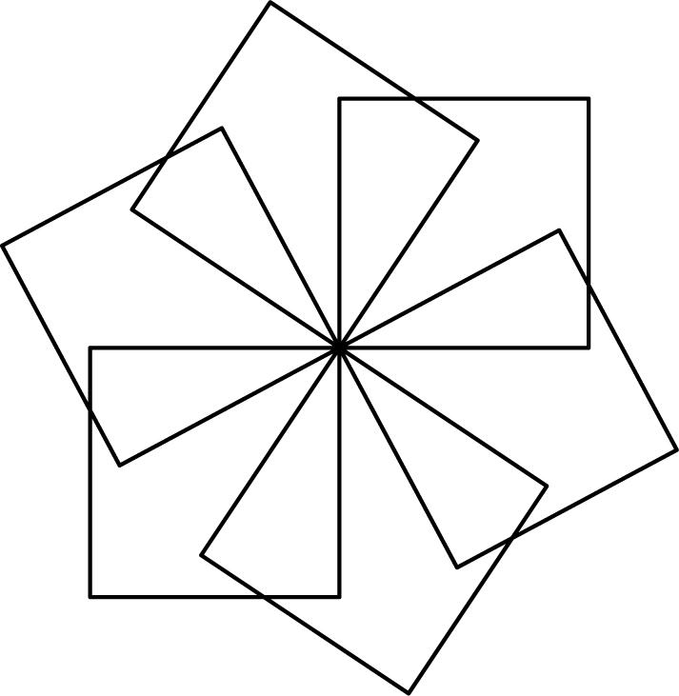

This abstracted flower design is made up of squares. The four internal angles of a square are all 90 degrees.

Try to make your code as short as possible by making use of a procedure.

3. When you have finished, take a screenshot of your flower and paste it here:

4. Copy and paste your code here and then add comments explaining what each line of code does.

